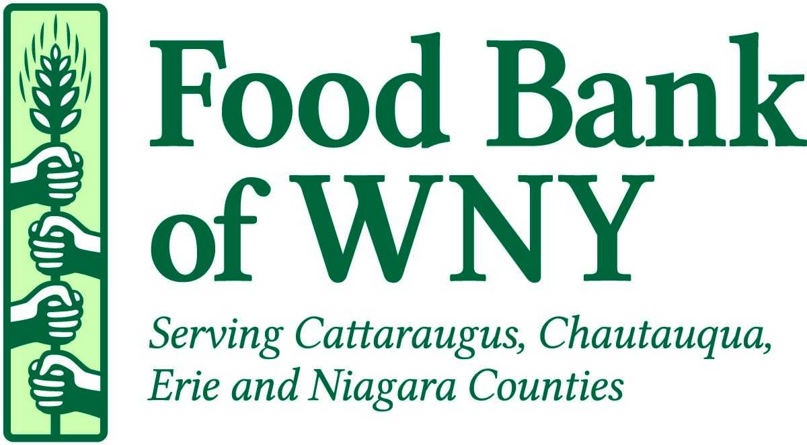
91 Holt St., Buffalo, New York 14206
Phone: (716) 852-1305 Fax: (716) 852-7858 www.foodbankwny.org

Client Story Collection Toolkit

Client Story Collection is a great way to learn more about the community members that make use of your agency. The answers to these questions can remain anonymous, if the client wishes. The Food Bank of WNY can use the answers to these questions to learn how we can best advocate for and better serve community members in need. We can also use these answers to help our community partners better understand the reality of hunger in Western New York. If clients are willing, the Food Bank may be interested in sharing their story in one of our publications, as well.

Included in this Toolkit:
- This cover sheet with instructions for use
- Client Story Collection Form
- Client Story Consent Form

Our experience and anecdotes from throughout the Food Bank of WNY’s network have given us an idea of the best way to collect stories from clients in a respectful & compassionate way.

Some tips:
- Designate one or more volunteers to sit down with willing clients to collect their stories
  - Be sure to pick a very outgoing, friendly, and compassionate volunteer – maybe someone whom clients are familiar with from your “check-in” table.
- Instead of handing the Collection and Consent Forms to clients and asking them to fill them out, have your designated volunteer(s) sit with clients, ask them the questions, and record the answers while the client tells them their story. This is useful for the following reasons:
  - It reduces embarrassment and literacy-based barriers for people who cannot read or write well.
  - It provides an opportunity for volunteers to get to know clients better.
  - Volunteers can help clarify questions. The Food Bank of WNY wants to hear clients’ personal stories about what’s happening in their lives and the role your agency plays in their life. Volunteers can help encourage clients to share that kind of information instead of getting “into the weeds” by talking about small details like the types of products available at the pantry. While product feedback from clients is an important thing to collect, this is not the goal of this particular project.

Other Important Instructions:
- Make sure each client fills out (with the help of a volunteer) a Consent Form.
- Keep Consent and Collection Forms together so that the Food Bank of WNY can tell which go together.
- Return Collection & Consent Forms to Catherine Shick at the Food Bank of the WNY via email at cshick@foodbankwny.org, fax or postal mail.
- Contact Catherine Shick at cshick@foodbankwny.org or at (716) 935-6692 with any further questions or concerns.

Story Sharing Consent Form

The Food Bank of WNY is collecting and sharing stories from our neighbors across our region. Our goal is to share real stories of those who currently experience or have experienced hunger and food insecurity. We are specifically looking for stories to share in our quarterly newsletter, on our website and on our social media platforms to show the impact the Food Bank and our network of agencies have in the community. This form gives us permission to share your story in different ways.

Please check the following that apply to your story:

- I give my consent to the Food Bank of WNY to share my story with my elected officials.

- I give my consent to the Food Bank of WNY to anonymously use my story in Food Bank publications, online and for general business.

- I give my consent to the Food Bank of WNY to use my real name and my story in Food Bank publications, online and for general business.

- I give my consent to the Food Bank of WNY to contact me to discuss and learn more about my story for future use by the Food Bank (fill in contact information):

Your Name (please print) _____________________________

Date _____________________________

Signature Permission _________________________________________________

Contact Information:

Address __________________________________________

City, State, Zip _____________________________________

Phone number _____________________________________

Email address ______________________________________

Questions? Call the Food Bank of WNY at (716) 852-1305 and ask for the Communications Department.

Thank you for sharing your story!
91 Holt St., Buffalo, New York 14206
Phone: (716) 852-1305 Fax: (716) 852-7858 www.foodbankwny.org

91 Holt St., Buffalo, New York 14206
Phone: (716) 852-1305 Fax: (716) 852-7858 www.foodbankwny.org

Sample Questions for Story Collection

Thank you for sharing your story! Your answers will help inform how the Food Bank of WNY and our member agencies can better serve and advocate for community members in need. Your answers can remain anonymous, if you wish.

If you are willing, the Food Bank of WNY may be interested in sharing your story in our newsletter, on our website or through social media. Please fill out the consent form to let us know which ways we can share your story, if at all.

- Tell me about your household. Who lives with you (spouse, children, grandparents)? What is their employment status? Health status? Age? Are they veterans or in the military?

- Why is this pantry/soup kitchen/agency important to you [and your family]?

- Some people have not experienced hunger. What would you like them to know about your experience?

Your name:____________________________________

Town you live in:________________________________

Questions? Call the Food Bank of WNY at (716) 852-1305
and ask for the Communications Department.

