A Guide to Food Dating

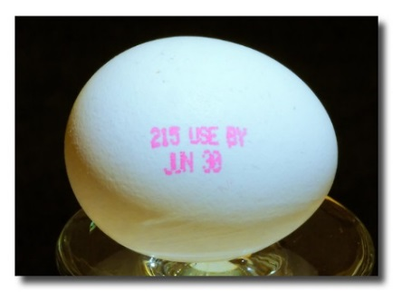
What do the dates mean? Manufacturers provide dating to help consumers and retailers decide when food is of best quality. Except for infant formula, dates are not an indicator of the product’s safety and are not required by Federal law.

What types of dates might be on a food product?

- "Sell-By" date tells the store how long to display the product for sale for inventory management. It is not a safety date. Perishable foods like milk, cheese, and meats usually have sell by dates. The sell by date tells the store up to what date a food item can remain on the shelf to be sold.
- "Best if Used By/Before" date - indicates when a product will be of best flavor or quality. It is not a purchase or safety date.

- “Use-By" date is the last date recommended for the use of the product while at peak quality. It is not a safety date except for when used on infant formula.
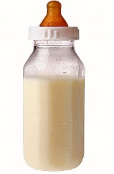
Infant formula and baby food is required to have a “Use-by” date and should not be purchased or used once this date has passed. This date has to do with nutrient retention as well as quality.

Are foods safe to eat after the date has passed? Foods that have been handled and stored properly may still be safe to eat.
Proper storing:
- Shelf stable foods should be kept in a clean, dry, cool place
- Refrigerated foods should be stored in the fridge, at a temperature of 40° or below
- Frozen foods should be stored in the freezer, at a temperature of 0° or below
Refer to the Food Keeper guide for specific information on food storage and shelf life. FoodKeeper app: https://www.foodsafety.gov/keep-food-safe/foodkeeper-app

